|  |
| --- |
| Lectures by Ravula govardhan (SUBSCRIBE & click bell) |
| HTML Complete Tutorial |
| Front End Development |
|  |
| **By Ravula Govardhan sir** |

|  |
| --- |
| Front End Development – HTML (Full Crash Course) |

**HTML Tutorial for Beginners:**

**Table of Content:**

1. What is HTML?
2. HTML Features
3. Editors in HTML
4. HTML structure
5. Comments in HTML
6. Elements in HTML
7. HTML Basic Tags
8. HTML Attributes
9. **What is HTML?**

* HTML stands for Hypertext Markup Language
* Hypertext means Link between web pages
* Markup Language means Text between tags which defines structure
* HTML is a language to create web pages
* HTML defines how the web page looks and how to display content with the help of elements
* HTML defines the structure of our web page
* HTML need to save your file with .html extension

1. **HTML Features**

* HTML is easy to learn.
* HTML creates effective presentations.
* HTML adds links easily from one page to another.
* HTML can display documents on all platforms like Windows, Linux, MAC etc...
* In HTML adding videos, graphics and audios making it more attractive.
* HTML case insensitive language.

1. **Editors in HTML**

* Notepad is the Simple editor
* Notepad++
* Atom
* Sublime Text is the Best editor

1. **HTML Structure**

<!DOCTYPE html>

<html>

<head>

<title></title>

</head>

<body>

</body>

</html>

1. **Comments in HTML**

* HTML comments are not displayed in the browser, but they can help document your HTML source code.
* HTML comments help to understand our code better and make it readable.
* HTML having 3 ways to comment: Single line, Multiple line, Comment tag // supported by IE

1. **Elements in HTML**

* HTML elements are created using tags
* HTML elements are used to define semantics (a specific meaning)
* HTML elements can be nested and empty
* For example:

<p color="red">This is our first paragaraph</p>

**Types of elements in HTML:**

There are two display values:

1. Block-level Elements

2. Inline Elements

1**. Block-level Elements:**

* A block-level element always starts on a new line.
* A block-level element always takes up the full width available.
* A block level element has a top and a bottom margin, whereas an inline element does not.

|-------------------------------------------|

|The <div> element is a block-level element.|

|-------------------------------------------|

* Here are the block-level elements in HTML:

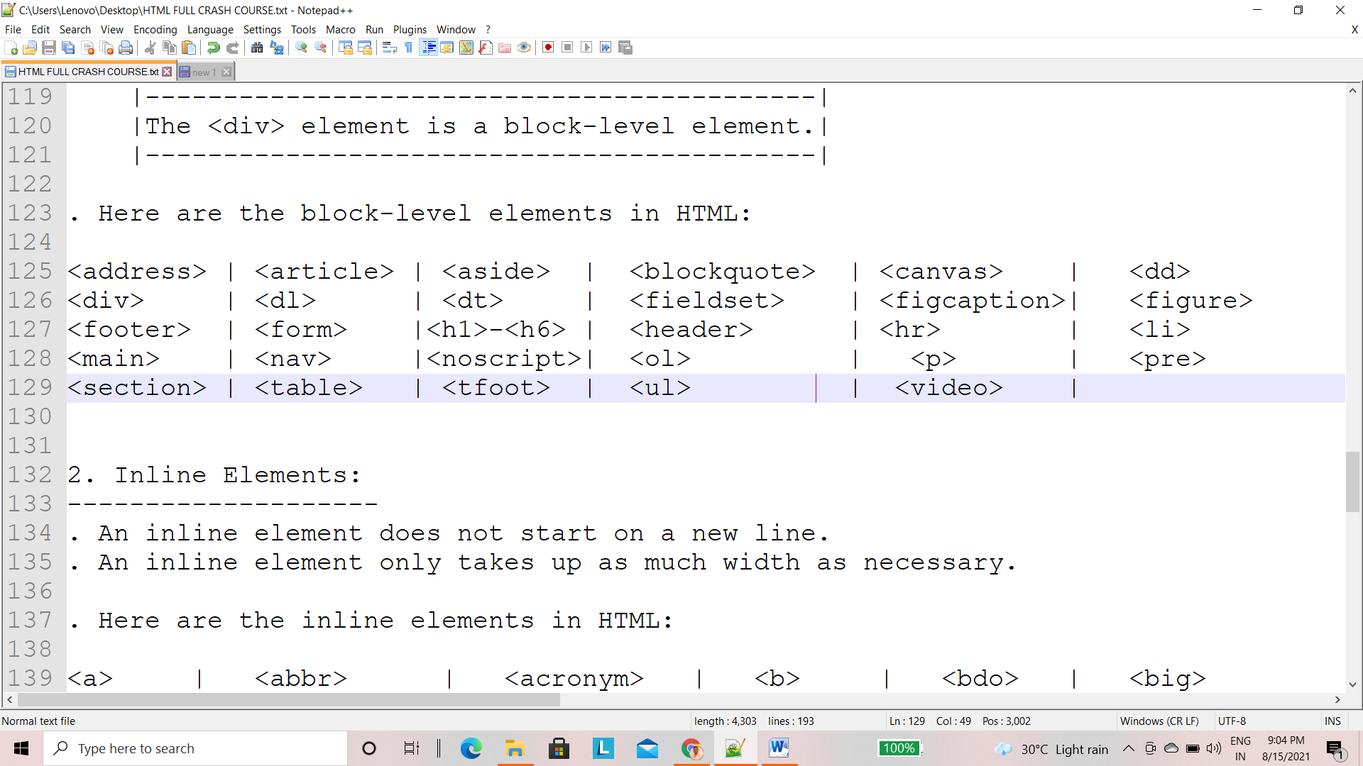

**2. Inline Elements:**

* An inline element does not start on a new line.
* An inline element only takes up as much width as necessary.
* Here are the inline elements in HTML:

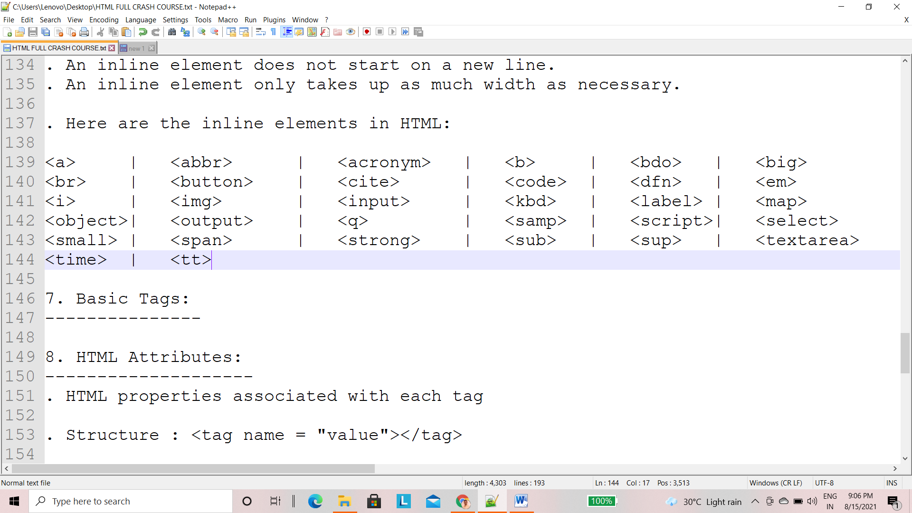

1. **Basic Tags:**

* HTML enclosed with <>
* In HTML we have different tags render different meaning.
* HTML **<title>** tag
* Whatever is written this tag comes up in the webpage’s tab
* It defines page title.
* Syntax: <title>Home page</title>
* HTML **<p>** tag
* P tag defines the paragraph
* Syntax: <p>This is Paragraph</p>
* **Self-closing tags List:**
* HTML **<hr>** tag
* Hr tag stands for horizontal rule.
* Dividing the web page neatly into parts.
* HTML **<br>** tag
* HTML stands for break line.
* Br tag moving to next line.
* HTML **<img>** tag
* Image tag is mainly used to add images in the webpages.
* **<h1>…<h6>** tags in HTML
* <h1>…<h6> tags stands for Heading tag.
* It defines heading of a webpage.
* H1 represents most important heading in the page.
* H6 represents most least important heading in the page.
* HTML **<strong>** tag
* <strong> tag defines text to be bold.
* <b> tag replaced with <strong> tag in HTML5.
* HTML **<em>** tag
* <em> tag defines the text to be italic
* <i> tag replaced with <em> tag in HTML5.
* HTML **<ol>** tag
* <ol> tag means ordered list
* <ol> tag define series of events that take place in some order
* Example making a coffee
* <ol>.........</ol>
* HTML **<ul>** tag
* <ul> tag means unordered list
* <ul> tag define series of events that take place where order is not important.
* Example your hobbies
* <ul>.........</ul>
* HTML **<li>** tag
* <li> tag defines the list item
* <li> tag in HTML used inside the ‘ol’ and ‘ul’ tag to define the events
* <li>…</li>
* **HTML <div> and <span> tags**
* Both of these are used to group different tags.
* HTML <div> & <span> acts like a container.
* Very useful while styling in HTML
* <div>…</div>
* <span>…</span>
* <div> is an block-level element and <span> is an in-line element.
* HTML **<Img**> tag
* <img>tag used to add images in a web page.
* Syntax: <img src=”url”>
* Self-closing tag
* HTML **<a>** tag
* HTML <a> tag used to add hyperlinks in a web page.
* Example: This is <a href=”url”>Google</a>.
* HTML **<table>** tag
* The basis of a **table**, used to format tabular data.
* We have many other tags for completing a table in a webpage.
* <tr> tag for table row creation.
* <th> tag for table head creation.
* <td> tag for table column creation.
* In table everything written in <tr> tag
* <thead> tag used for holding all header data in a webpage.
* <tbody> tag used for holding all body data in a webpage.
* HTML **<form>** tag
* Action attribute: Action attribute clearly specifies the URL to send form data to Method attribute: Method attribute specifies the type of HTTP request (GET or POST).
* Example: <form action="/my-form-submitting-page" method="POST">
* <input>: used to take data from the user as input.
* Some types of inputs are:

1. Text
2. Password
3. Placeholder
4. Button
5. Submit button
6. Checkbox
7. Radio button
8. <select>
9. Text Areas
10. Labels
11. For validations: required, email
12. **HTML Attributes**

* HTML properties associated with each tag
* Structure : <tag name = "value"></tag>

Global attributes:

* Global attributes are attributes common to all HTML elements; they can be used on all elements, though they may have no effect on some elements.
* Title: Adds extra information (hover)
* Style: Adds style information (font, background, color, size)
* <img src="url" width="100">
* src: used in image tag to define path
* Width: used to define width in pixels
* Alt: alternate text if image is not loaded
* <a href="url">Name of the link</a>
* <href> tag used to define path of the link.

Lectures by Ravula Govardhan – Youtube Channel (Subscribe & Click Bell) for more Programming Tutorials in Telugu.